Fact sheet

Facts and figures about the world record:
- The world record route from Preda to Alvaneu is 24,930 metres long.
- This involves climbing 789.4 metres in altitude (Preda = 1788.7 m above sea level; Alvaneu = 999.3 m above sea level).
- The world record journey leads over 48 bridges and through 22 tunnels.
- The largest viaduct on the world record route is the world-famous Landwasser viaduct shortly after Filisur with a length of 142 metres and a height of 65 metres.
- The longest tunnel on the world record route is the Greifenstein tunnel shortly before Filisur with 698 metres.
- The world record drive will generate 4000 kWh with regenerative braking.
- The world record train will travel at 30 to 35 km/h.
- The record-breaking journey takes around an hour.
- The record-breaking train weighs around 2990 tonnes.
- Communication within the platoon is ensured by means of a nearly 2-kilometre-long field telephone from the Civil Defence.
- In addition, 7 train drivers and 21 technicians are deployed on the train in order to be able to run the train.
- The Albula tunnel will be closed to rail traffic for around 12 hours. Trains will only run as far as Bergün during these 12 hours. During the world record attempt, the line will be closed to rail traffic for around 4 hours between Tiefencastel and Bergün.

Technical challenges
Never before has such a long passenger train travelled in the world, let alone in the high mountains on a narrow-gauge railway with tight curve radii, many tunnels and viaducts. This results in various challenges that have to be mastered in advance and during the journey.
Synchronous control of train formation and management of braking forces  The 25 trains all have to accelerate or brake at the same time, although only four trains at a time can be controlled from the same driver's cab. An electric loop ensures that all trains brake at the same time in case of emergency braking. Due to the heavy weight of the train (2'850 t without passengers), very high forces act on infrastructure and wagons in case parts of the train do not work synchronously. An intercom system in the train, training of the drivers and clear commands ensure the appropriate result. In addition, special software is loaded for the journey of the record-breaking train and the mechanical braking power is reduced. | 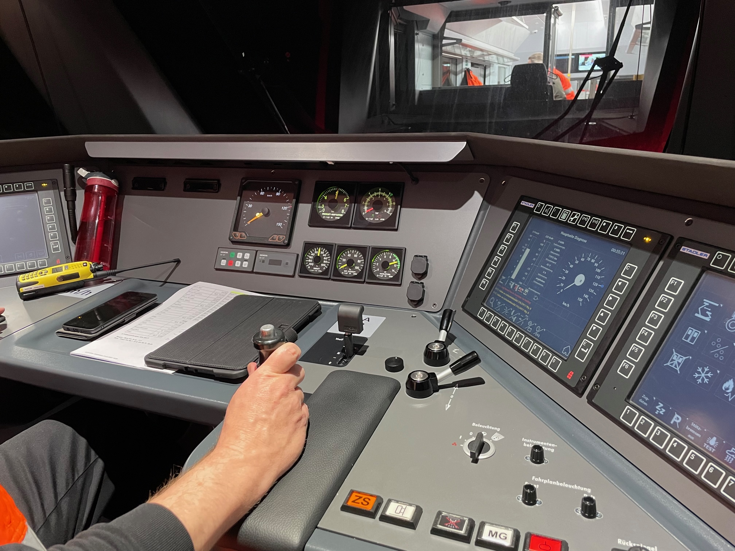
Recuperation and effects on grid load  On the descent, the train is braked completely via electrical recuperation. This produces electricity that is fed into the overhead line and can be used by other trains on the RhB network (but also by other railways in Switzerland and abroad). In addition, the surplus electricity can also be fed into the public grid (e.g. in Bever) via converters. The big challenge is that the voltage of the overhead line could increase too much (normally 11,000 volts), as 25 trains are delivering power synchronously in the same section. The overvoltage could not be absorbed by individual systems that are connected to the traction current. Various tests were carried out and measures are being taken for the record run (e.g. limitation of speed and acceleration, reduction of recuperation through special train software, preventive transfer of systems to local network power supply). | 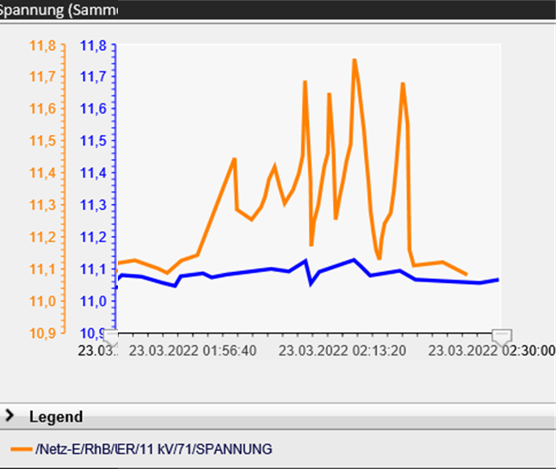
Connection of the trains  The individual 4-part partial trains (Capricorns) are connected with a fully automatic coupling. Four trains each are controlled by one driver. Coupling between four Capricorn trains at a time is mechanical and pneumatic, but not electrical. For this purpose, additional safety control lines are laid between the trains. | 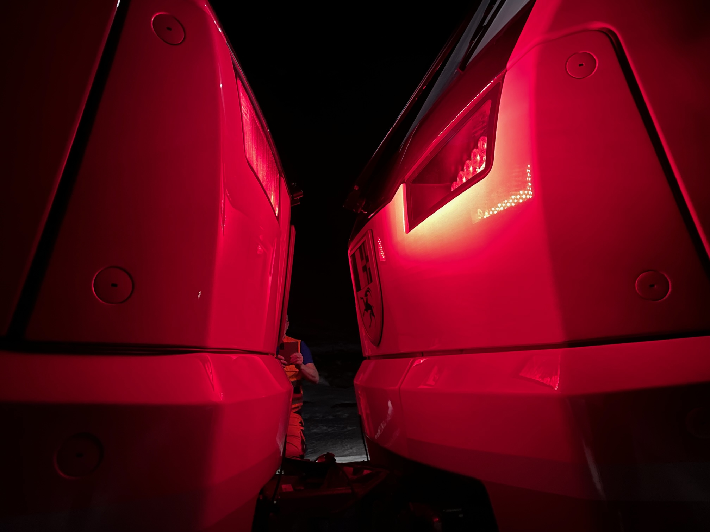
Ensuring security and availability of track and systems  The track is closed to other trains for the record run. The record train is partly longer than various block sections. The journey is controlled from the operations centre in Landquart. It must be ensured that the signals, but also the level crossings and customer information are triggered at the right moment. | 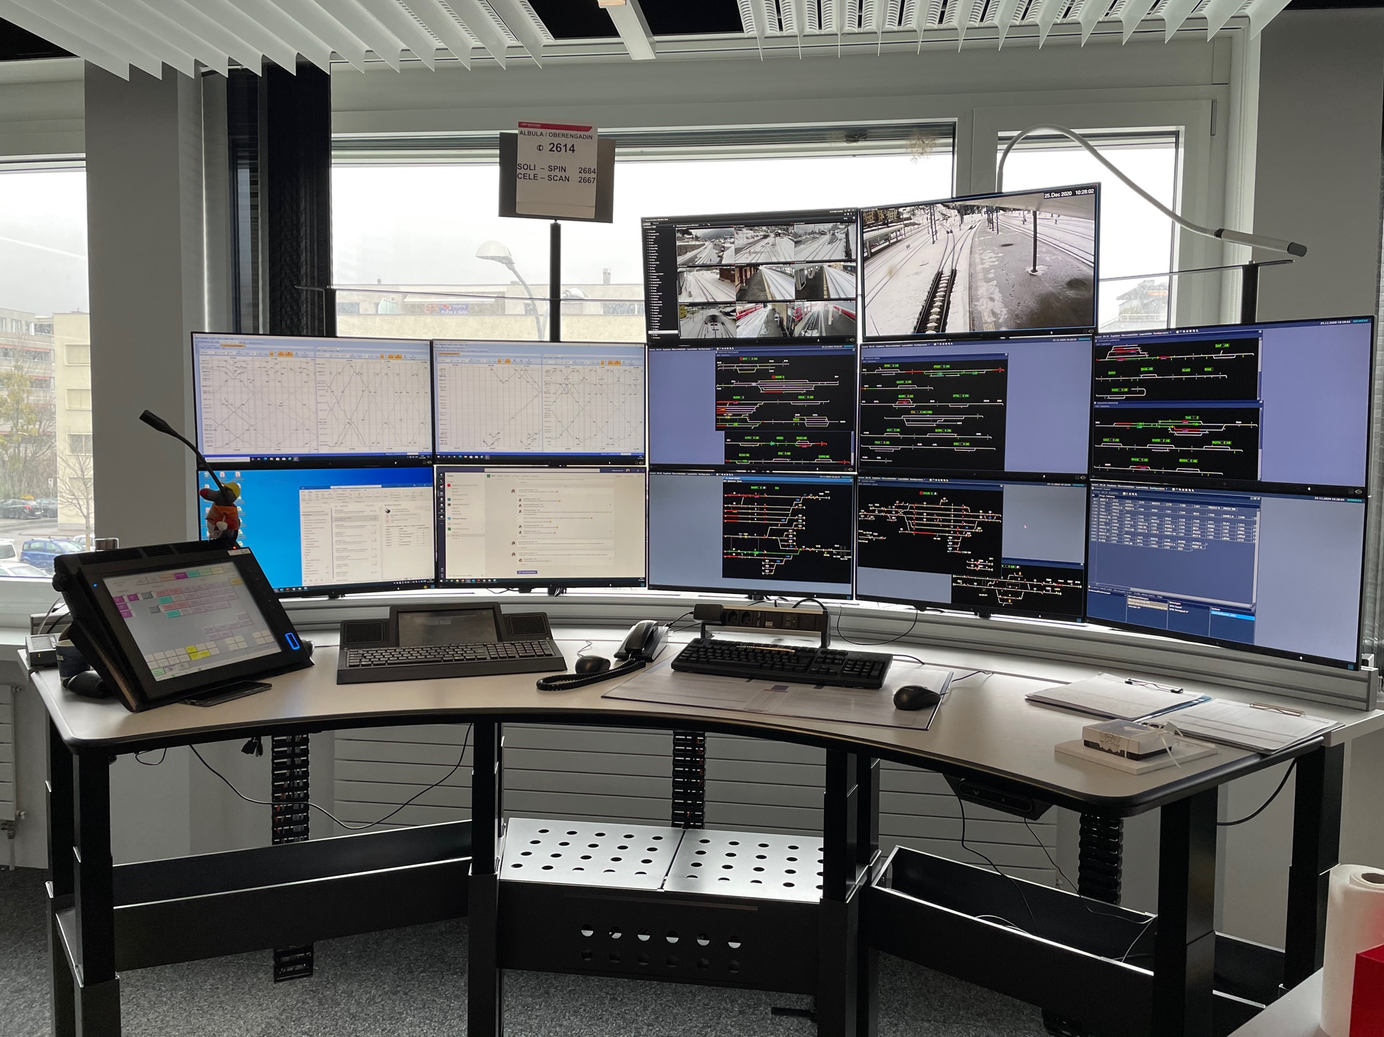
Live media production  The record drive is recorded (by Blick) by means of a live production and distributed via various channels. For this, a wide variety of cameras from drones, in the driver's cab and on the track are used and have to be processed in real time. This alone is a big (and exciting) challenge on a track with limited mobile phone coverage. | 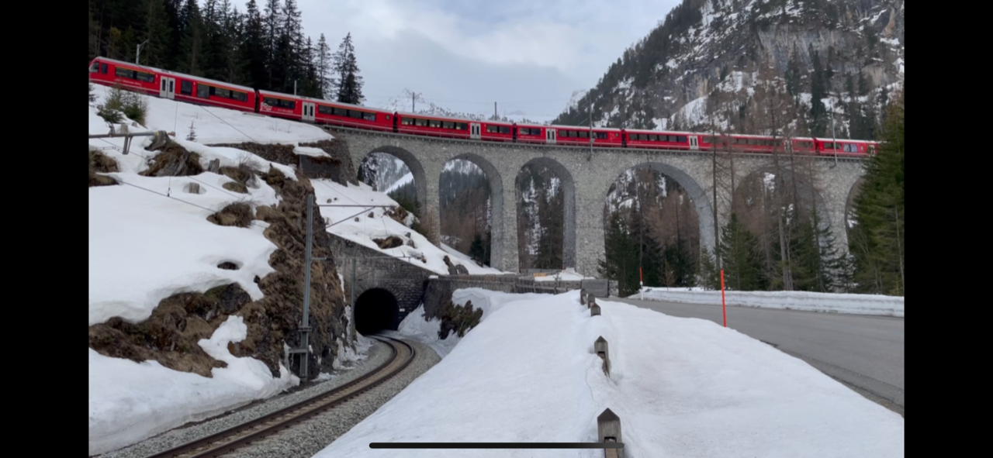
The timetable  Finally, the timetable for this 29 October 2022 is also a very special challenge. The first 13 multiple-unit trains will already be formed in the Samedan area on Friday night and placed in the Albula tunnel. During Saturday morning, four more trainsets will be brought up from Chur as regular passenger trains, added and wired. The vehicle rotations on this day are not the usual ones on almost all lines. At the same time, a railway intermittent operation is set up. For the world record attempt, there will be a special timetable between Chur and St. Moritz on the Albula line on this day. And when the world record attempt is over shortly after 3 p.m., the 25 multiple-unit trains will be distributed on the network again the same day, so that operations can resume as normally as possible on Sunday. | 